**Objective:** You are hired by a reputed software company which is going to design an application for "Movie Rental System". Your responsibility is to design a schema named MRS and create a table named Movie(id, Title, Genre, Language, Length). Write a program to design a GUI form to take input for this table and insert the data into table after clicking the OK button.

**Theory:**

**JDBC:**

JDBC stands for Java Database Connectivity. JDBC is a Java API to connect and execute the query with the database. It is a part of JavaSE (Java Standard Edition). JDBC API uses JDBC drivers to connect with the database. There are four types of JDBC drivers:

* JDBC-ODBC Bridge Driver,
* Native Driver,
* Network Protocol Driver, and
* Thin Driver

**Source Code:**

import java.awt.*;

import java.awt.event.*;

import javax.swing.*;

import java.sql.*;

public class Movie extends JFrame implements ActionListener {

    JFrame jf;

    JTextField t1, t2,t3,t4;

    JLabel l1,l2,l3,l4;

    JButton b1;

    public Movie(){

        jf = new JFrame("Movie Rental System");

        l1= new JLabel("Title");

        l2= new JLabel("Genera");

        l3= new JLabel("Language");

        l4= new JLabel("Length");

        t1= new JTextField(10);

        t2= new JTextField(10);

        t3= new JTextField(10);

        t4= new JTextField(10);

        b1= new JButton("ADD");

        jf.add(l1);

        jf.add(t1);

        jf.add(l2);

        jf.add(t2);

        jf.add(l3);

        jf.add(t3);

        jf.add(l4);

        jf.add(t4);

        jf.add(b1);

        jf.setSize(500,700);

        jf.setLayout(new FlowLayout());

        b1.addActionListener(this);

        jf.setVisible(true);

        jf.setDefaultCloseOperation(JFrame.EXIT_ON_CLOSE);

    }

    public void actionPerformed(ActionEvent ae){

        try{

            Class.forName("com.mysql.cj.jdbc.Driver");

            Connection conn=DriverManager.getConnection("jdbc:mysql://localhost:3306/mrs","root","");

            Statement stmt= conn.createStatement();

            System.out.println("Database connected successfully");

            String sql="insert into movie(title, genera, language, length) values (?,?,?,?)";

            PreparedStatement ps= conn.prepareStatement(sql);

            ps.setString(1, t1.getText());

            ps.setString(2, t2.getText());

            ps.setString(3, t3.getText());

            ps.setString(4, t4.getText());

            ps.executeUpdate();

            conn.close();

            System.out.println("Inserted successfully");

        }catch(Exception se){

        System.out.println(se);

        }

    }

    public static void main(String[] args) {

    new Movie();

}

}

**Output:**

Inserting data into from GUI to Mysql Database as:

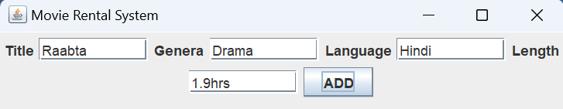

As we can see on VS code terminal:

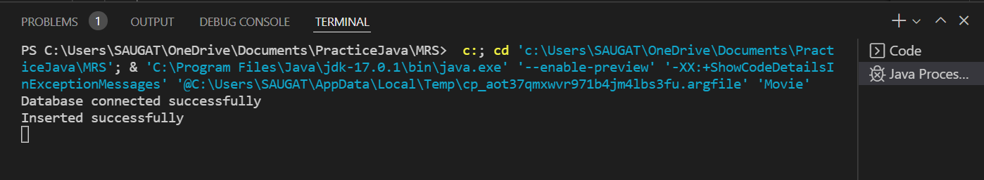

And, the reflected data in the database:

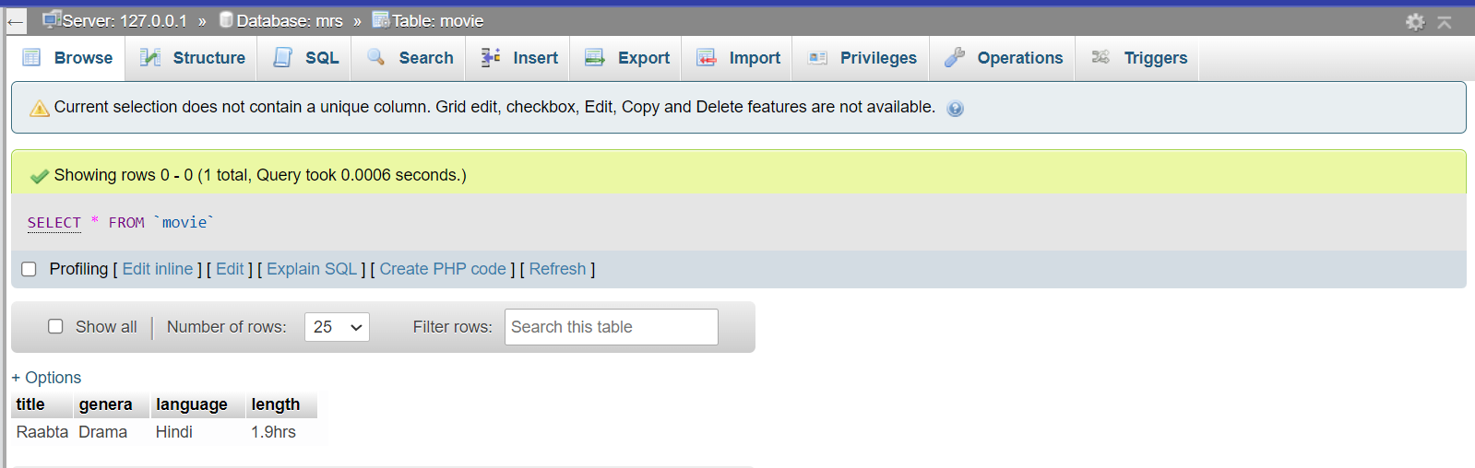

**Conclusion:**

In this lab session, we successfully connect to the MySQL database using JDBC connection using above Movie Rental System GUI.